Committed to delivering a safe environment
www.safegolf.org
for golf

Is something worrying you?
Do you need someone to talk to?
Speak to your club welfare officer
g.shillinglaw@outlook.com

07392447808
Graeme Shillinglaw

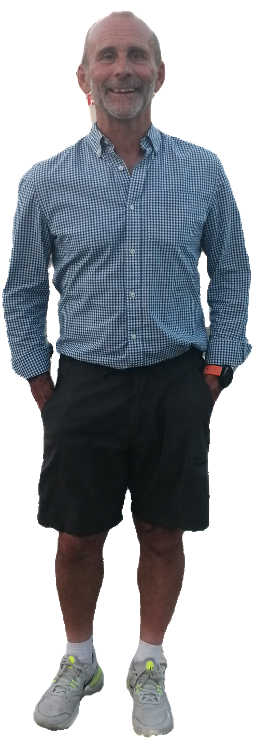

Alternatively, you can speak to someone at
ChildLine 0800 1111
ABOUT ME

Golf should be fun and enjoyable.
You should feel safe when taking part.

If something, or someone, is worrying you, please talk to me. I will take your concerns seriously and do whatever I can to help solve the problem.

NSPCC 0808 800 5000
England Golf 01526 351851
Club
WELFARE
officer

